Issue Date: 24 August 2015 Reviewed: January 6, 2020
Section 1: Identification
1a. Product Identifier: Titanium Alloys
1b. Other means of identification: Titanium Alloys as noted in ASTM & AMS Specifications
1c. Name, address and phone number of supplier of safety data sheet:
Titanium Industries, Inc.
18 Green Pond Road
Rockaway, New Jersey 07866
973-983-1185
1d. Emergency Phone Number: Chemtrec 1-800-424-9300 (USA) 703-527-3887 (outside USA)
1e. Recommended use of Titanium Alloys and restrictions on use: Titanium Alloy Distribution
Section 2: Hazard(s) Identification
2a. Classification: This chemical is not considered hazardous by the 2012 OSHA Hazard Communication Standard (28 CFR 1910.1200)
This SDS is written for articles, titanium alloys supplied in the solid form and not subject to REACH Regulation (EC) No 1907/2006 and is not subject to classification under CLP Regulation (EC) No 1272/2008.
2b. Pictogram: Not available
2b. Precautionary Statement: May cause damage to the respiratory tract, liver, and kidney through repeated or prolonged inhalation. When product is subject to welding, burning, melting, sawing, brazing, grinding, buffing, polishing, or other heat generating processes, potentially hazardous airborne particles and/or fumes may be generated.
2c. Hazards not otherwise classified: None known
2d. Unknown toxicity statement: None known
Section 3: Composition/Information on Ingredients
3a. Chemical Name, common name, synonyms, CAS/EC number, identifiers, concentrations
CAS – Chemical Abstract Service EC – European Community
Titanium contains small amounts of trace elements. Titanium Alloys contain alloying elements which are intentionally added to make the metallurgical requirements for numerous applications.
Chemical identity of regulated substances under 29 CFR 1910.1200 (Hazard Communication Standard)
Chemical Name | CAS Number | EC Number | Weight %
Titanium | 7440-32-6 | 231-142-3 | 90-98%
Aluminum | 7440-90-5 | 231-072-3 | 3-6%
Vanadium | 7440-62-2 | 231-171-1 | 2-4%
Nickel | 7440-02-0 | 231-111-4 | 0-0.9%
Molybdenum | 7439-98-7 | 231-107-2 | 0-0.4%
Tin | 7440-31-5 | 231-141-8 | 0-4.5%
Chromium | 7440-47-3 | 231-157-5 | 0-11%
Zirconium | 7440-67-7 | 231-142-3 | 0-1%
Chemical identity of substances NOT regulated under 29 CFR 1910.1200 (Hazard Communication Standard). These are components of other grades for reference.
Palladium | 7440-05-3 | 231-115-6 | 0-0.25%
Iron | 7439-89-6 | 231-096-4 | 0-0.5%

Section 4: First-Aid Measures
4a. Necessary first aid instructions:
Inhalation: In the event dust particulate, fumes, or smoke is inhaled during processing, move to fresh air and consult a qualified health professional if feeling ill.
Skin Contact: In case of an allergic skin reaction, seek a qualified health professional.
Eye Contact: In the event dust particulate enters the eye, flush eyes repeatedly and seek a qualified medical professional if condition persists.
Ingestion: Not a suspected route of exposure however if during processing, dust particulates are ingested and conditions exist, seek a qualified medical professional.
4b. Description of most important symptoms or effects:
Respiratory System- operations such as welding, burning, sawing, brazing, machining and grinding may irate the respiratory tract, see
Section 8.
4c: Recommendations for immediate medical care: None known
Section 5: Fire-Fighting Measures
5a. Recommendations of suitable extinguishing equipment: Titanium Alloys are not flammable as distributed but is flammable in the form of fines or turnings resulting from processing. In this case the recommended extinguishing media would be to use a Class D Dry Powder fire extinguisher.
Recommendations of unsuitable extinguishing equipment: DO NOT SPRAY WATER on burning particulate.
5b. Specific hazards arising from Titanium Alloys: Dust, turnings, or fine pieces may ignite easily when presented with an ignition source.
5c. Special PPE and precautions for firefighters: MSHA/NIOSH approved SCBA apparatus and full typical firefighting protective gear.
Section 6: Accidental Release Measures
6a. Personal precautions and protective equipment: Not applicable in solid state. If dust or turnings are accumulated, personnel are recommended to wear appropriated PPE to protect against airborne particulate coming in contact with eyes or skin.
6b. Emergency procedures: Use personal protective gear as required
6c. Methods and materials used for containment: Not applicable as distributed
6d. Cleanup procedures: Use personal protective gear as required
Section 7: Handling and Storage
7a. Precautions for safe handling: Not applicable as distributed. Dust, turnings, or small particulate should be handled in a manner to protect against eye or skin contact by utilizing gloves and/or breathing masks where required.
7b. Recommendations on the conditions for safe storage including any incompatibilities: Not applicable as distributed however for small pieces, turnings, etc… keep away from ignition sources.
Section 8: Exposure Controls/Personal Protection
8a. Occupational exposure limits:
Chemical | OSHA PEL¹ | ACGIH TLV² | NIOSH REL³ | IDLH⁴
Titanium | 15 mg/m³ (TiO₂, total dust) | 10 mg/m³ (TiO₂) | LFC ( TiO₂) ⁵ | 5000 mg/m³ (TiO₂)
Aluminum | 15 mg/m³ ( total dust, PNOR⁶)  5.0 mg/m³ ( respirable fraction, PNOR) | 10 mg/m³ ( metal dust)  5.0 mg/m³ ( welding fume) | 10 mg/m³ ( total dust)  5.0 mg/m³ ( respirable dust) | NE
Vanadium | “C” 0.5 mg/m³ ( V₂O₅, respirable dust)  “C” 0.1 mg/m³ ( V₂O₅, fume) | 0.05 mg/m³ ( V₂O₅, inhalable fraction)⁷ | “C” 0.05 mg/m³ ( V₂O₅, total dust or fume) | 35 mg/m³ ( V, dust or fume)
Nickel | 1.0 mg/m³ ( Ni metal & insoluble compounds) | 1.5 mg/m³ ( inhalable fraction Ni metal)  0.2 mg/m³ ( inhalable fraction Ni inorganic only insoluble and soluble compounds) | 0.015 mg/m³ ( Ni metal & insoluble and insoluble compounds) | 10 mg/m³ ( Ni)
Molybdenum | 15 mg/m³ ( total dust, PNOR)  5.0 mg/m³ ( respirable fraction, PNOR) | 10 mg/m³ ( Mo insoluble compounds, inhalable fraction)  3.0 mg/m³ ( Mo insoluble compounds, respirable fraction)⁸  0.5 mg/m³ ( Mo insoluble compounds, respirable fraction) | NE | NE
Zirconium | 15mg/m³ ( total dust, PNOR)  5.0/m³ ( respirable fraction,  PNOR | 2.0 m/m³ ( metal and inorganic  compounds, Sn) | NE | NE
Chromium | .5 mg/m³ ( Cr II & III,  inorganic compounds  - mg/me ( Cr, metal)  0.005 mg/mg/m³ ( Cr VI, inorganic  Compounds & certain water insoluble)”AL” 0.0025 mg/m³ ( Cr VI, inorganic compounds)  water insoluble) | 0.5 mg/m³ ( Cr III , inorganic compounds)  .5 mg/m³ ( Cr, metal)  0.05 mg/m³ ( Cr VI, inorganic compounds)  0.01 mg/m³ ( Cr, VI inorganic compounds  water insoluble | 0.5 mg/m³ (as Cr II & III inorganic compounds)  0.5 mg/m³ ( Cr, metal)  0.001 mg/m³ ( Cr VI, inorganic compounds)  water insoluble | 250 mg/m3 ( Cr II & metal)  25 mg/m3 ( Cr III )  15 mg/m3 ( Cr VI)
NE – None Established
- OSHA PELs (Permissible Exposure Limits) are 8-hour TWA (time weighted average) concentration unless otherwise noted. A (“C”) designation denotes a ceiling limit, which should not be exceeded during any part of the working exposure unless otherwise noted. A Short Term Exposure Limit (STEL) is defined as a 15 minute exposure, which should not be exceeded at any time during a work day.
- Threshold Limit Values (TLV) established by the American Conference of Governmental Industrial Hygienists (ACGIH) are 8-hour TWA concentrations unless otherwise noted. ACGIH TLVs are for guidance purposes only and as such are not legal, regulatory limits for compliance purposes.
- The National Institute for Occupational Safety and Health Recommended Exposure Limits (NIOSH-REL): Compendium of Policy and Statements, NIOSH, Cincinnati, Oh (1992). NIOSH is the federal agency designated to conduct research relative to occupational safety and health. As is the case with ACGIH TLVs, NIOSH RELs are for guideline purposes only and as such are not legal, regulatory limits for compliance purposes.
- The immediately dangerous to life or health air concentration values (IDLHs) are used by NIOSH as part of respirator selection criteria and were first developed in the mid 1970s by NIOSH. The documentation for Immediately Dangerous to Life of Health Concentrations (IDLHs) is a compilation of the rationale and sources of information used by NIOSH during the original determination of 387 IDLHs and their subsequent review and revision in 1994.
- LFC- Lowest Feasible Concentration, refer to Section 11, Toxicological Information.
- PNOR (Particles Not Otherwise Regulated). All inert and nuisance dusts, whether mineral, inorganic, or organic, not listed specifically by substance name or covered by the PNOR limit which is the same as the inert or nuisance dust limit of 15 mg/m³ for total dust and 5.0 mg/m³ for the respirable fraction (containing less than 1% crystalline silica)
- Inhalable fraction. The concentration of inhalable particulate for the application of this TLV is to be determined by the fraction passing a size selector with the characteristics defined in the ACGIH 2009 TLVs® and BEIs® (Biological Exposure Indices) Appendix D paragraph A.
- Respirable fraction. The concentration of respirable dust for the application of this limit is to be determined from the fraction passing a size selector with the characteristics defined in the ACGIH 2009 TLVs® and BEIs® (Biological Exposure Indices) Appendix D paragraph C.
8b. Appropriate engineering controls: Use controls as appropriate to minimize exposure to metal fumes and dusts during handling operations. Provide general or local exhaust ventilation systems to minimize airborne concentrations. Local exhaust is necessary for use in enclosed or confined spaces. Provide sufficient general/local exhaust ventilation in pattern/volume to control inhalation exposures below current exposure limits.
8c. Recommendations for personal protective measures(PPE):
Respiratory Protection: Seek professional advice prior to respiratory selection and use. Follow OSHA respiratory regulations (29 CFR 1910.134) and, if necessary, use only a NIOSH-approved respirator. Select respirator based on its suitability to provide adequate worker protection for given working conditions, level of airborne contamination, and presence of sufficient oxygen. A concentration of air in the various contaminents determines the extent of respiratory protection needed. Half-face, negative-pressure, air-purifying respirator equipped with P100 filter is acceptable for concentrations up to 10 times the exposure limit. Full-face, negative-pressure, air-purifying respirator equipped with P100 filter is acceptable for concentrations up to 50 times the exposure limit. Protection from air-purifying negative-pressure and powered air respirators is limited. Use a positive-pressure-demand, full face, supplier air respirator, or self contained breathing apparatus (SCBA) for concentrations above 50 times the exposure limit. If exposure is above the IDLH (Immediately Dangerous to Life or Health) for any of the constituents, or there is a possibility of an uncontrolled release or exposure levels are unknown, then use a positive-demand, full-face, supplied air respirator with escape bottle of SCBA.
Warning! Air purifying respirators, both negative-pressure, and powered air do not protect workers in oxygen-deficient atmospheres.
Eyes: Wear appropriate eye protection to prevent eye contact. For operations, which result in elevated temperature of the product to or above its melting point or result in the generation of airborne particulates, use of safety glasses or goggles to prevent eye contact. Contact lenses should not be worn where industrial exposures to this material are likely. Use safety glasses or goggles as required for welding, burning, sawing, brazing, grinding or machining operations.
Skin: Wear appropriate personal protective clothing to prevent skin contact with abrasive surfaces. Cut resistant gloves and sleeves should be worn when working with sharp titanium alloy products. For operations which result in elevating the temperature of the product to or above its melting point, or result in the generation of airborne particulates, use protective clothing, and gloves to prevent skin contact. Protective gloves should be worn as required for welding, burning, or handling operations.
Other protective equipment: An eyewash station or shower should be readily available in the work area when operations which could result in fumes and/or particulates are being performed.
Section 9: Physical and Chemical Properties
9a. Appearance (physical state, color, etc…): Solid metal
9b.Upper/lower flammability or explosive limits: N/A
9c. Odor: Odorless
9d.Odor threshold: N/A
9e.Vapor pressure: N/A
9f. Vapor density (air = 1): N/A
9g. pH: N/A
9h. Relative density: 5-6 (H₂o =1)
9i. Melting point/freezing point: >2800ºF
9j. Solubility: Water insoluble
9k. Flash point: N/A
9l. Evaporation rate: N/A
9m.Flamability (solid/gas): Non flammable, non combustible
9n. Partition coefficient: n-octanol/water: ND
9o. Auto ignition temperature: N/A
9p.Decomposition temperature: ND
9q.Viscosity: N/A
N/A – Not applicable
ND – Not determined
Section 10: Stability and Reactivity
10a. Reactivity: Not determined (ND) for product as a whole
10b. Chemical stability: Titanium Alloy products are stable under normal storage and handling conditions
10c. Possibilities of hazardous reactions: None Known
10d. Conditions that should be avoided: Storage with strong acids or calcium hypochlorite
10e. Classes of incompatible materials: Molten metal may react violently with water
Section 11: Toxicological Information
Toxicological information has not been established for this product as sold. However, processing of this product in operations such as high temperature (welding, burning), sawing, brazing, machining, and grinding may produce fumes or particulates, which would result in the material being classified as hazardous under OSHA 29CFR 1910.1200. The categories of Health Hazards as defined in “ Globally Harmonized System of Classification and Labeling of Chemicals (GHS), Third revised edition ST/SG/AC.10/30/Rev 3” United Nations, New York and Geneva, 2009 have been evaluated and are listed below:
Potential Hazard | Hazard Category | Hazard Symbol | Signal Word | Hazard Statement
Skin Irritation | 3^{b} | No Symbol | Warning | Causes mild skin irritation
Eye Damage / Irritation | 2B^{c} | No Symbol | Warning | Causes eye irritation
Skin Sensitization | 1^{d} | 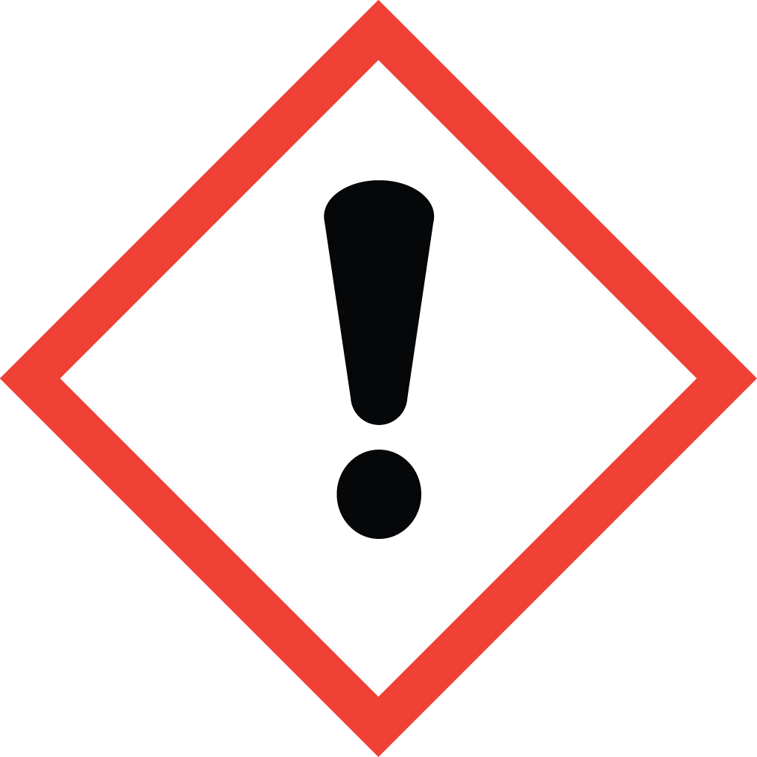 | Warning | May cause an allergic skin reaction
Carcinogenicity | 2^{f} | 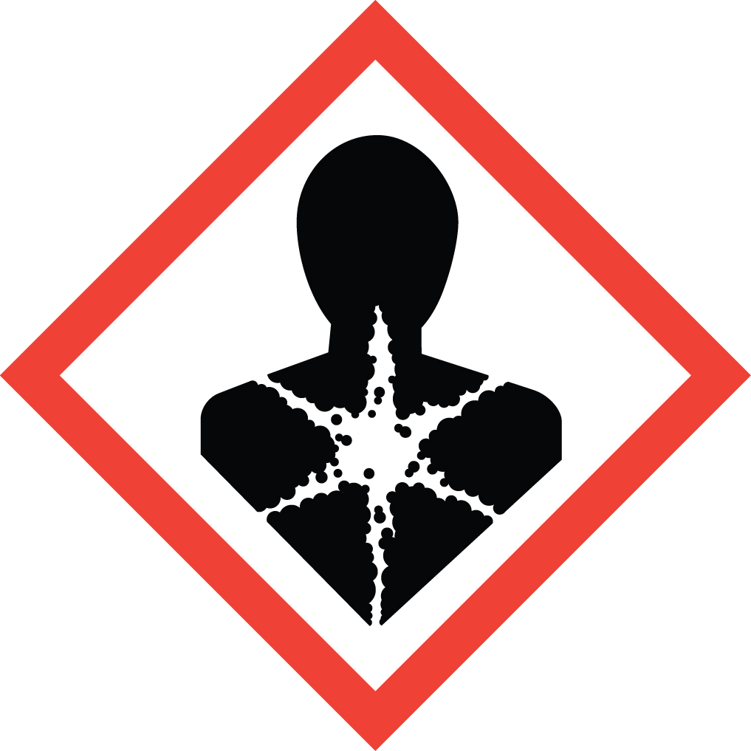 | Warning | Suspected of causing cancer
Toxic Reproduction | 2^{h} |  | Warning | Suspected of damaging the unborn child
Specific Target Organ Systemic Toxicity (STOST) following Single Exposure | 3^{i} |  | Warning | May cause respiratory irritation
STOST following Repeated Exposure | 1^{j} |  | Danger | Causes damage to lungs through prolonged or repeated inhalation exposure.  Causes damage to the central nervous system.

Notes:
- No LC₅₀ or LD₅₀ has been established for Titanium Alloys. The following data has been determined for the components:
Nickel: LD₅₀>9000mg/kg (oral/Rat); LC₅₀>10.2 mg/1 (inhalation/Rat)
- No Skin (Dermal) Irritation No data is available for Titanium Alloys. The following Skin (Dermal) Irritation information was found for the components:
Nickel: Slight irritation only in rabbits
Molybdenum: Irritating
- No Eye Irritation data is available for Titanium Alloys. The following Eye Irritation information was found for the components:
Molybdenum: Causes eye irritation
Nickel: Slight eye irritation from particulate abrasion only
- No Skin (Dermal) Sensitization No data is available for Titanium Alloys. The following Skin (Dermal) Sensitization information was found for the components:
Nickel: Human skin sensitizer
- No Germ Cell Mutagenicity No data is available for Titanium Alloys. The following Mutagenicity and Geotoxicity information was found for the components:
Nickel: Positive results in vitro and in vivo but insufficient data for classification
Aluminum: Not mutagenic in vitro; but has marginal effects in vivo
- Carcinogenicity: IARC, NTP, and OSHA do not list Titanium Alloys as carcinogens. The following Carcinogenicity information was found for the components:
Welding Fumes, IARC Group 2B carcinogen, a mixture that is possibly carcinogenic to humans
Nickel and certain nickel compounds – IARC group 2B carcinogens that are possibly carcinogenic to humans. Insoluble nickel compounds – ACGIH confirmed human carcinogen. Nickel – EURAR insufficient evidence to conclude carcinogenic potential in animals or humans; suspect carcinogen classification Category 2 Suspected of causing cancer. Nickel Oxide – HSDB listed as Category 1a, may cause cancer. Human data in which exposure to nickel refinery dust caused lung and nasal tumors.
- No Toxic Reproduction data available for Titanium Alloys. The following Toxic Reproduction information was found for the components;
Nickel: Oral administering to experimental animals caused fetetoxicity
Aluminum: May cause delay in development of neurobehavioral indices
- No Specific Target Organ Systemic Toxicity (STOST) following a Single Exposure data available for Titanium Alloys.
The following STOST following a single exposure data was found for the components;
Molybdenum: May cause respiratory irritation
j. No Specific Target Organ Systemic Toxicity Repeated Exposure data was not available for Titanium Alloys. The following STOST Repeated Exposure data was found for the components:

Nickel: Rats exposed to Nickel by inhalation at 1mg/m³ for 90 days developed lung inflammation, hyperplasia and fibrosis
Aluminum: Chronic exposure to aluminum flake has been reported to cause pneumoconiosis in workers. Repeat oral exposure to aluminum results in
decrements in neurobehavioral function and development.
The above toxicity information was determined from available scientific sources to illustrate the prevailing posture of the scientific community. The scientific resources includes: The American Conference of Governmental Industrial Hygienist (ACGIH) Documentation of the Threshold Limit Values (TLVs) and Biological Exposure indices (BEIs) with other Worldwide Occupational Exposure Values 2009. The International Agency for Research on Cancer (IARC), The National Toxicology Program (NTP) updated documentation, The World Health Organization(WHO) and other available resources, The International Uniform Chemical Information Database (IUCLID), European Union Risk Assessment Report (EU-RAR), Concise International Chemical Assessment Documents (CICAD) European Union Scientific Committee for Occupational Exposure Limits (EU-SCOEL), Agency for Toxic Substances and Disease Registry (ATSDR), Hazardous Substance Data Bank (HSDB), and International Program on Chemical Safety (IPCS)
Section 12:Ecological Information (non-mandatory)
12a. Hazard Category: Not reported
12b. Hazard Symbol: No symbol
12c. Signal Word: No signal word
12d. Hazard Statement: No hazard statement
12e. Ecotoxicity: No data available for Titanium Alloys. However individual components of the product have been found to be toxic to the environment. Metal dusts may migrate into soil and groundwater and be ingested by wildlife as follows:
Aluminum: LC₅₀>100mg/1 for fish and algae
12f. Mobility: No data available for Titanium Alloys.
12g. Persistence and Degradability: No data available
12h. Bioaccumulative Potential: No data available
The listings and regulations relating to a titanium alloy product may not be complete and should not be solely relied upon for all regulatory compliance responsibilities.
Section 13: Disposal Considerations (non-mandatory)
13a. Disposal: Titanium Alloy scrap should be recycled whenever possible. Product dusts and fumes from processing operations should also be recycled, or classified by a competent environmental professional and disposed of in accordance with applicable federal, state or local regulations.
13b. Container Cleaning and Disposal: The product as supplied does not posses characteristics which qualify as hazardous waste. Following processing and use, resulting titanium turnings, powders, fines and/or swarf will impact cleaning and disposal and should be evaluated by a competent environmental professional.
Note: The information is for Titanium Alloy in its original form. Any alterations can void this information.
Section 14: Transport Information (non-mandatory)
Transportation Information: The following listings of regulations relating to titanium alloy product may not be complete and should not be solely relied upon for all regulatory compliance requirements.
The US Department of Transportation (DOT) under 49 CFR 172 does not regulate Titanium Alloys as a hazardous material. All federal, state and local laws and regulations that apply to the transport of this type of material must be adhered to.
Shipping Name: N/A  Shipping Symbols: N/A  Hazard Class: N/A  UN No.: N/A  Packing Group: N/A  DOT/IMO Label: N/A  Special Provisions (172.102): N/A | Packaging Authorizations  a) Exceptions: N/A  b) Group: N/A  c) Authorization: N/A | Quantity Limitations  a) Passenger, Aircraft or Railcar: N/A  b) Cargo Aircraft Only: N/A  Vessel Stowage Requirements  a) Vessel Stowage: N/A  b) Other: N/A  DOT Reportable Quantities: N/A

International Maritime Dangerous Goods (IMDG) and the Regulations Concerning the International Carriage of Dangerous Goods by Rail (RID) classification, packaging, and shipping requirements follow the US Department of Transportation Hazardous Materials Regulation.
Regulations the International Carriage of Dangerous Goods by Road (ADR) does not regulate titanium as a hazardous material.
Shipping Name: N/A  Classification Code: N/A  UN No.: N/A  Packing Group: N/A  ADR Label: N/A  Special Provisions: N/A  Limited Quantities: N/A | Packaging  a) Packing Instructions: N/A  b) Special Packaging Provisions: N/A  c) Mixed Packaging Provisions: N/A | Portable Tanks and Bulk Containers  a) Instructions: N.A  b) Special Provisions: N/A
International Air Transport Association (ITA) does not regulate Titanium Industries titanium as a hazardous material
Shipping Name: N/A  Class/Division: N/A  Hazard Label: N/A  UN No.: N/A  Packing Group: N/A  Excepted Quantities (EQ): N/A | Passenger and Cargo Aircraft Limited Quantity (EQ)  Packaging Inst: N/A  Max Net Qty/Pkg: N/A | Cargo Aircraft Only Pkg. Instructions: N/A  Max Net Qty/Pkg: N/A | Special Provisions: N/A  ERG Code: N/A
Pkg – Packing Max Net Qty/Pkg – determined by the freight carrier capability
Transport Dangerous Goods (TDG) Classification: Titanium Alloy does not have a TDG classification.
Section 15: Regulatory Information (non-mandatory)
Regulatory information: The following listing of regulations relating to Titanium Alloy product may not be complete and should not be solely relied upon for all regulatory compliance responsibilities.
This product and/or its constituents are subjected to the following regulations:
OSHA Regulations: Air Contaminant (29 CFR 1910.1000, Table Z-1, Z-2, Z-3): Titanium Alloy is not listed. However, individual components of the product are listed: Refer to Section 8, Exposure Controls and Personal Protection.
EPA Regulations: Titanium Alloy is not listed. However individual components of the product are listed:
Components | Regulations
Aluminum | SWDA, SARA 313
Vanadium | SARA 313
Nickel | CAA, CWA, SARA 313, CERCLA, RCRA, SDWA
Molybdenum | SDWA
Chromium | CERCLA, CWA, SARA 313, RCDA, SDWA
SARA Potential Hazard Categories: Immediate Acute Health Hazard: Delayed Chronic Health Hazard
Regulations Key
CAA – Clean Air Act (42 USC Sec. 7412: 40 CFR Part 61 [as of 8/2/2006])
CERCLA – Comprehensive Environmental Response, Compensation and Liability Act (42 USC secs. 9601(14), 9603(a), 40 CFR sec.302.4, Table 302.4 and App. A)
CWA – Clean Water Act (33 USC Secs. 1311;1314(b), (c), (e), (g); 136(b), (c); 137(b), (c) [as of 8/2/2006])
RCRA – Resource Conservation Recovery Act (42 USC Sec.6921;40 CFR Part 261 App. VIII)
SARA – Superfund Amendments and Reauthorization Title III Section 302 Extremely Hazardous Substances (42 USC secs. 11023, 13106; 40 CFR Sec.372.65) and section 313 Toxic Chemicals (42 USC secs. 11023, 13106; 40 CFR sec. 372.65 [as of 6/30/2005])
TSCA – Toxic Substance Control Act (15 U.S.C.s/s 2601 et seq.[1976])
SDWA – Safe Drinking Water Act (42 U.S.C.s/s 300f et seq. [1974])
Section 313 Supplier Notification: Titanium Alloys contains the following toxic elements subject to the reporting requirements of section 313 of Title III of the Superfund Amendments and Reauthorization Act of 1986 and 40 CFR part 372:
CAS # | EC # | Chemical Name | Max Percent by Weight
7429-90-5 | 231-072-3 | Aluminum | 7
7440-62-2 | 231-171-1 | Vanadium | 4.5
7440-02-0 | 231-111-4 | Nickel | 0.9
This information should be included in all SDS’s that are copied and distributed for this material
State Regulations: The Product, Titanium Alloy is not listed in any state regulations. However, individual components of the product are listed in various state regulations:
Pennsylvania Right to Know: Contains regulated material in the following categories:
Hazardous Substances: Nickel, Molybdenum, and Aluminum
Environmental Hazards: Aluminum (dust and fume), Nickel and Vanadium
Special Hazard Substances: Nickel
California Prop. 65: Titanium Alloys may contain trace elements, generally much less than 0.1% of metallic elements known to the state of California to cause cancer or reproductive toxicity. This includes Nickel.
New Jersey: Contains regulated material in the following categories:
Special Health Hazards Substances: Nickel
Hazardous Substance List: Titanium, Molybdenum, Vanadium, Aluminum (dust and fume), and Nickel
Environmental Hazards: Not Listed
Minnesota: Nickel (elemental, soluble, and insoluble compounds) and Aluminum (dust and fume)
Massachusetts: Aluminum (dust and fume), Nickel, Vanadium, and Molybdenum

Other Regulations:
WHMIS Classification (Canadian): Titanium Alloys is not listed. However individual components are.
Ingredients | WHMIS Classification
Titanium | D26
Vanadium | D3B
Nickel | D2B
Molybdenum | B4, D2B
This product has been classified in accordance with the hazard criteria of the Controlled Products Regulations and the SDS contains all the information required by the controlled Products Regulations.
Section 16: Other Information
16a. Hazardous Material Identification System (HMIS)
National Fire Protection Association (NFPA)


Health Hazard | 1
Fire Hazard | 0  0
Physical Hazard | 0  1  0

HEALTH-1 Denotes possible chronic hazard if airborne dusts or fumes are generated irritation or minor reversible injury possible
FIRE- 0 Materials will not burn
PHYSICAL HAZARD-0 Materials that are normally stable, even under fire conditions, and will not react with water, polymerize, decompose, condense or self react. Non-explosives

16b. National Fire Protection Association (NFPA)
Health-1 Exposure could cause irritation but only minor residual injury even if no treatment is given
Flammability-0 Materials that will not burn
Instability-0 Normally stable, even under fire exposure conditions, and are not reactive with water

DISCLAIMER:
The data in this Safety Data Sheet is correct to the best of our knowledge at the date of this publication. All information, recommendations and suggestions concerning the product are based on data believed to be reliable. It is the user’s responsibility to determine the safety, toxicity and suitability for their own use of the product. The information given is a guideline for safe handling, processing, storage, transportation and disposal. Since the applications of the product is beyond our control, no guarantee or warranty is expressed or implied is made by Titanium Industries Inc. It is the user’s responsibility to comply with all federal, state and local regulations. This SDS is not intended to serve as a complete regulatory compliance document.

